11. Initial Design Decisions
Assignment 2 Task 1 researched two CivicConnect design problems and recommended an approach for each. This section records the final project decision for each problem, says where it follows or departs from the A2 recommendation and why, and names the code that will carry it. The research is referenced by A2 section rather than repeated. A third decision, email verification at registration, was not part of A2; it is recorded in 11.3 with its own evidence. Decisions are logged in Section 17 as D11, D12 and D13.
11.1 DP-01: requester notifications and channel volatility (D11)
Problem in CivicConnect terms
When a request's status changes, the requester must get meaningful feedback (REQ-006). ASR-008 and REQ-026 ask for at least two channels and require that channels can be added or replaced without touching core logic. Scope item S-IN-003, however, commits only in-app feedback and defers email/SMS (S-DEF-002). With email verification at registration (D13), the platform must send email anyway, so an email provider becomes a required dependency rather than an optional one.
A2 evidence and alternatives
- Candidate A, direct service with conditional selection (A2 §2.2): simplest, but each new channel edits the same class and leaks provider details into tests.
- Candidate B, Strategy contract with provider adapters (A2 §2.3): a narrow NotificationChannel interface, one implementation per channel and one adapter per external provider, chosen at the composition root.
- A2 recommended Candidate B, but set a condition (A2 §4): if only one channel is committed and provider volatility is not credible, keep the direct service and defer the Strategy.
Final decision
Follow the A2 recommendation (Candidate B). The A2 condition for Strategy is now met: ASR-008 names more than one channel, and the email provider is shared with registration confirmation, so it will change for reasons outside notifications (free-tier quotas, provider choice in M3). The design is:
- NotificationChannel interface with EmailNotificationChannel (built) and SmsNotificationChannel (deferred, S-DEF-002).
- Both registration confirmation and the email channel depend on one MailSender interface, implemented by a Nodemailer SMTP adapter (Figure 11-1). Changing provider changes one adapter and its settings.
- In-app feedback is not a channel: the requester's timeline reads the action table directly, so it cannot fail separately from the status change (S-IN-003 is met even if email fails).
- Whether status emails are actually sent depends on CR-005. If it is rejected, the handler is registered with no channels and in-app feedback remains; no code changes.

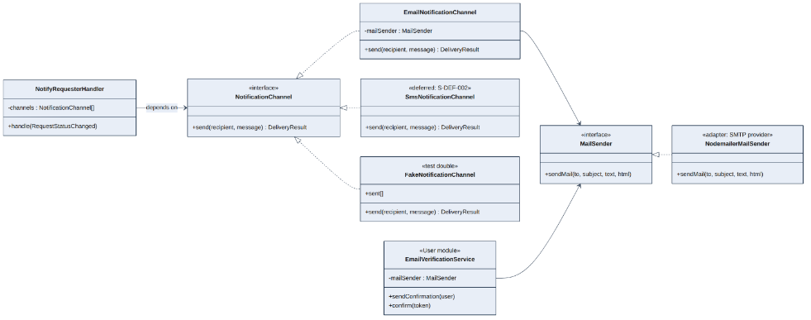
Figure 11-1. DP-01 class design. One mail adapter serves registration confirmation and notifications. SMS is shown only to mark where a future channel plugs in.
Table 11-1. DP-01 expected benefit, cost and verification
Aspect | Detail
Expected benefit | The Request module has no knowledge of how messages are delivered (Dependency Inversion). Adding SMS later is a new class and one registration line (Open-Closed). Email failures cannot roll back core writes (Section 12.1, R07).
Complexity introduced | Two small interfaces (NotificationChannel, MailSender), one result type, registration in the composition root. Every channel returns the same DeliveryResult meaning (Liskov Substitution).
Misuse to avoid | Returning provider objects from send(); adding templating, scheduling or receipts to the interface (Interface Segregation).
Affected code | program/backend/src/modules/notification/ (NotificationChannel, EmailNotificationChannel, NotifyRequesterHandler), program/backend/src/infrastructure/mail/NodemailerMailSender.js, composition root program/backend/src/app.js.
Acceptance | No module's domain/ folder or service.js imports Nodemailer or an SMTP setting; only infrastructure/mail/ does.
Tests (planned) | Unit: handler sends one message per status change using the fake channel; a failing channel is logged and does not throw. Integration: email reaches the Ethereal test inbox.
Traceability | REQ-006, REQ-026 → ASR-008 → D11 → Notification module → tests above. Scope conflict → CR-005.

11.2 DP-02: status changes and their side effects (D12)
Problem in CivicConnect terms
A status change (REQ-013, REQ-016, REQ-017) must validate the transition, update the request and write an attributable action row (REQ-021, ASR-009). It should also notify the requester (REQ-006) and, later, may trigger SLA escalation (S-DEF-001). If the service calls every reaction directly it grows with each new one; if everything becomes an event, the audit guarantee becomes hard to see and test.

A2 evidence and alternatives
- Candidate A, explicit application-service orchestration (A2 §3.2): visible order and one transaction, but fan-out coupling as reactions grow.
- Candidate B, in-process Observer through domain events (A2 §3.3): the publisher does not know its subscribers, but ordering, failure and transaction timing must be defined.
- A2 recommended a hybrid: orchestrate the mandatory, transactional work explicitly; publish one in-process event for optional reactions (A2 §3.5).

Final decision
Follow the A2 recommendation. The status service locks the service_request row, asks the domain object to apply the D10 transition, and writes the request update and the action row in one transaction. Only after COMMIT does it publish RequestStatusChanged to an in-process dispatcher. Handlers are not awaited by the HTTP response, so a slow SMTP server cannot push a status update past the 10-second boundary (REQ-025, ASR-005). Assignment, category correction and completion use the same pattern.
CivicConnect meets the A2 condition for adding events: two reactions that change for different reasons (notification now, escalation later) and one that must never be optional (the action row).
Table 11-2. Classification of every reaction to a status change
Reaction | Classification | Where it runs | If it fails
Validate transition (D10) | Mandatory | Domain object, before any write | Nothing written; 409 with the §12.4 error envelope
Update service_request status and owner | Mandatory, transactional | Status service, in the transaction | ROLLBACK; nothing written
Insert action row (StaffID, ActionType, PreviousStatus, NewStatus, Comment, Timestamp) | Mandatory, transactional | Status service, same transaction | ROLLBACK; status never changes without its audit row
logging row | Automatic | Database trigger (Section 8) | Diagnostic only; no effect on the command
Requester notification | Optional | NotifyRequesterHandler, after commit, not awaited | Logged with request ID; status change stands; timeline still shows it
Oversight counts | None needed | SQL at read time (Admin module) | Not applicable
SLA escalation | Optional, deferred (S-DEF-001) | Future handler | Not built in M2

Rules the team commits to
- Handlers run after commit, in registration order; a handler error is caught and logged and never rolls back the command.
- Handlers must not change the same request again (no event chains). The event carries data, not a repository.
- The dispatcher is a small in-house class. There is no message broker, retry queue or outbox because there is no distributed boundary (A2 §3.3, D06, D09).

Table 11-3. DP-02 expected benefit, cost and verification
Aspect | Detail
Expected benefit | The audit guarantee is visible in one method and one transaction (ASR-007, ASR-009). New optional reactions are added as handlers without editing the transition use case (ASR-008).
Complexity introduced | A dispatcher, an event type and handler registration. Tracing a status change means checking the handler list, so the dispatcher logs each handler it calls.
Affected code | program/backend/src/modules/request/service.js (changeStatus), modules/request/domain/ServiceRequest.js, shared/events/EventDispatcher.js, modules/notification/NotifyRequesterHandler.js.
Acceptance | ServiceRequest has no infrastructure imports. A forced action-insert failure leaves the status unchanged. A second handler can be registered without editing the request service.
Tests (planned) | Unit: every allowed and forbidden transition. Integration: status and action row always agree; forced failure rolls back; the dispatcher calls exactly the registered handlers.
Traceability | REQ-013, REQ-016, REQ-017, REQ-021, REQ-028 → ASR-007, ASR-009 → D10, D12 → code above → tests above.

11.3 Additional decision: email verification at registration (D13)
This decision was not part of the A2 research. In M2 the lecturer confirmed that new accounts must prove they own their email address. Users still register and sign in with email and password as baselined (REQ-023, REQ-030, ASR-003, bcrypt in §9). The only addition is a one-time confirmation email at registration: an account cannot sign in until its email address is confirmed. Because this adds acceptance criteria to REQ-023 and a small data change, it is raised as CR-004 (Section 18). Supporting evidence comes from the OWASP Cheat Sheet Series and NIST SP 800-63B-4.
Why verify the email
- The email address is the account's identity and, from CR-005, the channel for status notifications. A mistyped or someone else's address would send request updates to the wrong person.
- It stops accounts being created in another person's name and limits throw-away or automated sign-ups, which protects the staff worklist from junk requests.
- It gives a verified address for a password-reset flow later (M3).

Options considered
Table 11-4. Account verification options
Option | For | Against
A. No verification (current baseline) | Nothing to build; no email dependency | Any address can be used, including someone else's; notifications may go to the wrong person
B. Confirmation link emailed at registration (selected) | One email per account; familiar pattern; password sign-in unchanged; NIST treats email confirmation codes as outside its ban on email authentication | Depends on email delivery at sign-up; unverified accounts need a resend and clean-up rule
C. Email code at every sign-in (email as second factor) | Adds a second step to every login | NIST SP 800-63B-4 §3.1.3.1: email "SHALL NOT be used for out-of-band authentication"; one extra email per sign-in; slower for staff who sign in many times a day
D. Authenticator-app or passkey second factor | Strongest protection | More build and test effort than M2/M3 allow; candidate for staff and management accounts later

Final decision
Option B. Registration takes name, email and password (hashed with bcrypt as in §9). The account is saved with email_verified = no and the server emails a single-use confirmation link. Opening the link sets email_verified = yes and clears the token; from then on the user signs in with email and password as normal and receives the signed JWT from §12. A sign-in attempt on an unconfirmed account is refused with a clear message and a "resend confirmation email" button. Figure 11-2 shows the flow.

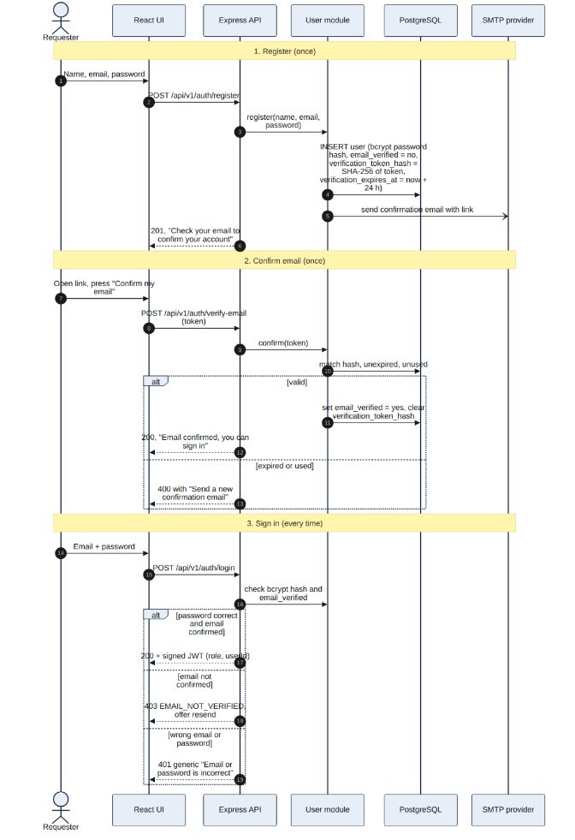
Figure 11-2. Registration with email confirmation, followed by normal email + password sign-in.

Table 11-5. Security controls for the confirmation token
Control | Design | Source
Unguessable token | 32 random bytes from Node's crypto.randomBytes | OWASP Forgot Password Cheat Sheet: tokens "generated using a cryptographically secure random number generator"
Nothing usable stored | Only a SHA-256 hash of the token is stored, in user.verification_token_hash, with user.verification_expires_at. No separate table is needed | OWASP: tokens "stored in a secure manner"
Single use, limited life | Valid for 24 hours; the hash is cleared on first use, so the link works once; "resend" overwrites the hash, which invalidates the old link | OWASP: tokens "invalidated after they have been used" and should expire
Rate limits | Registration and resend requests limited per email and per IP | OWASP: rate limiting
No account enumeration | Registering an address that already exists shows the same "check your email" page; the existing owner gets a "someone tried to register with your address" email instead | OWASP Authentication Cheat Sheet: "A link to activate your account has been emailed to the address provided"
Mail scanners | The link opens a page with a "Confirm my email" button that POSTs the token, so automatic link scanners cannot use it up; Referrer-Policy: no-referrer | OWASP Forgot Password Cheat Sheet, referrer leakage
Passwords | Unchanged: bcrypt hashing (ASR-003, REQ-030, D05) | Section 9

Trade-offs the team accepts
- Email delivery matters at sign-up. If the confirmation email does not arrive, the new user cannot start. The resend button and provider checks in M3 mitigate this (R14, R16).
- Unconfirmed accounts build up. Accounts not confirmed within 7 days are deleted by a scheduled clean-up (R15).
- This is verification, not two-factor sign-in. Every later sign-in is email and password only. A true second factor for staff and management is a candidate for M3 (option D).

Table 11-6. D13 affected code and verification
Aspect | Detail
Affected code | program/backend/src/modules/user/service.js (register, verifyEmail, login), modules/user/repository.js (three new user attributes), infrastructure/mail/NodemailerMailSender.js; routes POST /api/v1/auth/register, POST /api/v1/auth/verify-email, POST /api/v1/auth/resend-verification; POST /api/v1/auth/login returns 403 EMAIL_NOT_VERIFIED for unconfirmed accounts; frontend pages Register, CheckEmail, SignIn in program/frontend/src/pages/auth/.
Tests (planned) | Unconfirmed account cannot sign in; token works once; expired token rejected; resend invalidates the old token; duplicate registration shows the same page; stored value is a hash, never the raw token; password still stored as a bcrypt hash.
Traceability | REQ-023, REQ-033 → ASR-002, ASR-003 → D13, CR-004 → User module → tests above. Risks R14, R15, R16.

11.4 Research-to-decision summary
Table 11-7. How evidence informed the M2 design decisions
Problem | Evidence and recommendation | Decision | Same or different, and why
DP-01 Notification channels | A2 Task 1 §2.5, §4: Strategy + provider adapters; keep a direct service if only one channel | D11: Strategy + one shared mail adapter; SMS deferred | Same as A2. The A2 condition for Strategy is met (ASR-008, shared email provider).
DP-02 Status side effects | A2 Task 1 §3.5: explicit orchestration for mandatory work + in-process event for optional reactions | D12: as recommended, handlers not awaited | Same. Two independently changing reactions plus one mandatory audit write.
Account verification | Not in A2. Lecturer requirement; OWASP Authentication and Forgot Password cheat sheets; NIST SP 800-63B-4 | D13: confirmation email at registration, password sign-in unchanged | New decision; risks R14–R16.
Submission integrity (supporting) | A2 Task 2 §5.6: UI/API checks + database constraints; no cache | D08 and §12.3 (owned by teammates) | Same. The team still has to choose between idempotency keys (§12.3) and pre-save checks (D08).
Client–API boundary (supporting) | A2 Task 3 §6.3: synchronous REST | D06 (§12) | Same.

